CONCEPT DEVELOPMENT

_____________

TECHNICAL REPORT

TR-010

DEVELOPMENT OF AN ALTITUDE DETECTION ALGORITHM FOR THE IMAGENEX ECHO SOUNDER

AMY UNDERWOOD AND MATHIEU KEMP

JULY 09, 2014

**SUMMARY**

The Imagenex Model 852 Ultra-Miniature Echo Sounder was tested at altitudes from 0.5ft to 4.5ft where the total water depth was 5ft. A threshold algorithm was then developed to detect the measured altitude given the raw altimeter data. The results demonstrate our ability to detect altitudes greater than 0.45m. The algorithm correctly detects 75% of sampled altitudes, within ±10 cm of the real value.

# Table of Contents

1. Table of Contents 1

2. Introduction 2

3. Methods 3

3.1 Approach 3

3.2 Test Procedure 4

3.3 Theory 4

3.3.1 Nomenclature 4

3.3.2 Detection Threshold Algorithm 5

4. Results 7

4.1 Altimeter Raw Data & Threshold Algorithm 7

4.1.1 Altitude = 1.369 meters, total depth = 1.52 meters 7

4.1.2 Altitude = 1.012 meters, total depth = 1.52 meters 9

4.1.3 Altitude = 0.7341 meters, total depth = 1.52 meters 11

4.1.4 Altitude = 0.4563 meters, total depth = 1.52 meters 13

4.1.5 Altitude = 0.2976 meters, total depth = 1.52 meters 15

4.1.6 Altitude = 0.15 meters, total depth = 1.52 meters 17

4.1.7 Altitude Sweep 19

4.2 Threshold Algorithm Performance 20

5. Conclusions 23

6. Appendix A: Additional Results 24

6.1 Threshold (sigma) distributions 24

7. Appendix B: Description of Log Files 30

8. Appendix C: Imagenex 852 Echo Sounder Datasheet 31

# Introduction

The Imagenex Model 852 Echo Sounder is used on the SandShark vehicle to measure altitude. It is rated to detect altitudes from 0.5 m to 50 m. The ranges supported by the altimeter are 5, 10, 20, 30, 40, and 50 meters. The resolution of the sensor is inversely proportional to the range setting.

SandShark is expected to operate in water depths of 2 to 200m. The most stressful case that of very shallow waters, where multipath and reverberation effects are expected to pollute the altimeter returns.

Figure 1 shows raw data collected in 5 feet of water next to a dock piling. The signal shows a solid line – corresponding to the expected return from the seabed –, and a strong, diffuse reverberation component at later times. Our objective is to design an altitude detection algorithm that can isolate the seabed return from the reverberation down to 1m of water depth.



Figure 1 – Image of Raw Altimeter Data. The vertical axis shows intensity versus range, with zero range at the top. The horizontal axis is time, each vertical strip corresponding to a different ping.

This report describes the experimental procedure and development of the threshold detection algorithm, presents the results, and concludes with algorithm performance specifications.

# Methods

## Approach

The Imagenex Model 852 Echo Sounder was tested off the Bluefin floating dock at low tide. The depth of the water was 5ft. The following equipment was used:

* Imagenex Model 852 Ultra-Miniature Echo Sounder & PCB
* Laptop with 852.exe
* Altimeter bottle with 6ft of tygon tubing bringing up RS-485 and power
* 24VDC @ 1A power supply
* Sealevel RS485 to USB (P/N 2403)
* 12 lbs of weight – enclosed in the bottle
* 6 ft tether tied to bottle with flags indicating each foot from the transducer
* Extension cord
* AC Shore power
* DC4 grease – used on bottle’s seals

Figure 2 shows the altimeter bottle.

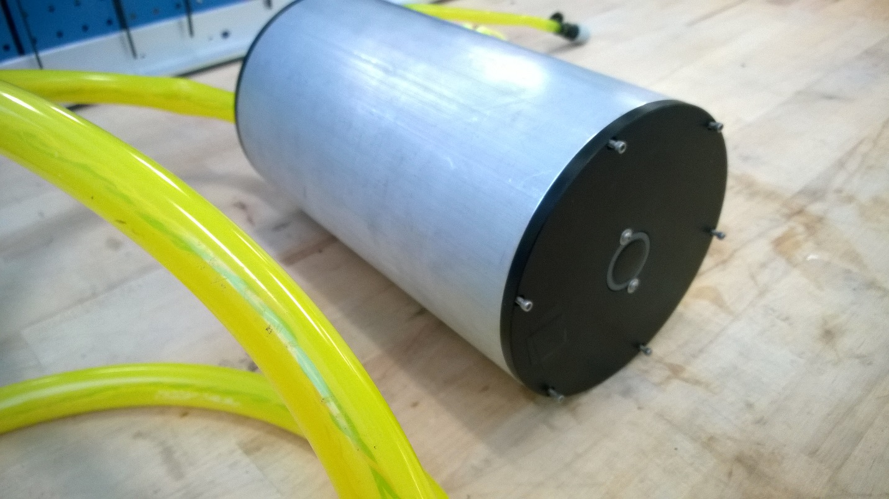

Echo sounder transducer

Figure 2 Altimeter transducer and electronics are housed in the bottle. Tygon tubing is used to bring up RS485 and supply power.

The Imagenex Model 852 Echo Sounder communicates over serial RS-485. In order to interface with the laptop, a Sealevel RS-485 to USB adapter was used. The laptop uses the 852.exe provided by Imagenex to log and visually inspect altimeter data. The altimeter was supplied with 24VDC and configured with the following settings:

* Range: 5 m
* Gain: 6 dB
* Pulse Length: 100 µsec

The altimeter’s transducer and electronics were mounted within the weighted bottle and lowered off the side of the Bluefin dock. Data was recorded for altitudes: 0.5 ft, 1 ft, 1.5 ft, 2.5 ft, 3.5 ft, 4.5 ft where the total depth was 5ft.

## Test Procedure

Testing proceeded as follows:

1. Power the altimeter with 24 VDC (< 1A)
2. Open serial communication with the altimeter using 852.exe and the Sealevel 2403
3. Measure and record the depth of the test area. This was done with a telescopic boat hook.
4. Lower the base of the bottle such that the altimeter is facing the seafloor, 0.5 ft below the surface, ±1”. Log altimeter data for at least 2 seconds.
5. Repeat step (3) for altitudes: 1 ft, 1.5 ft, 2.5 ft, 3.5 ft, 4.5 ft
6. Relocate the bottle to a very shallow location (total depth of 3 ft)
7. Sweep the bottle parallel to the seafloor (1ft to 2 ft altitude) while logging data
8. Note the composition of the seafloor at all testing locations.

Seafloor type for tests conducted in steps (3) and (4) was muddy. For testing convenience, the altimeter was positioned 0.15m from a wall stretching from the surface to the seafloor. For the test conducted in step (6), the seafloor was sandy.

## Theory

The following section defines the detection threshold algorithm.

### Nomenclature

|  |  |
| --- | --- |
|  | altitude detected (Eq. 3) |
|  | background signal level (Eq. 2) |
|  | detection threshold multiplier |
|  | altimeter raw data bin # (range = 1:1:252) |
|  | signal level of bin *i* (Eq. 1) |
|  | altimeter range setting |
|  | actual (reference) altitude |
|  | altitude detection tolerance |
|  | raw altimeter data sample (264 bytes) |
|  | probability of detection when there is an object to detect (Eq. 4) |
|  | probability of correct detection (Eq. 5) |
|  | probability of false alarm (Eq. 6) |

Note: The altitude signal is contained within bytes 13 to 264 of the raw output.

### Detection Threshold Algorithm

**Definition of bin signal level ():**

Each byte following the 12-byte header corresponds to bin intensity:

Equation 1

where A is the raw altimeter data sample, an array made up of 264 bytes.

**Definition of background signal level ():**

The background level is estimated from the mean intensity in the first 30cm of the return:

Equation 2

where  **where .**

As Appendix A shows, we found that 0.3m is sufficiently large to estimate the background level.

**Definition of altitude detected ():**

The altitude is equal to the range of the first return that crosses a certain threshold equal to γ*the background. Because it favors earlier returns, this algorithm is expected to reject signal reverberation which occurs much later:

**:**

Equation 3

**:**

Altitude is in meters. A value of -1 indicates absence of a valid altitude.

Definition of probability of detection ():

2x3 outcomes are possible:

|  |  |  |  |
| --- | --- | --- | --- |
|  | *Signal Detected within tolerance* | *Signal Detected outside tolerance* | *Signal Absent* |
| *Signal Present* | Good measurement (A) | Correct detection/incorrect altitude (B) | Miss (C) |
| *Signal Absent* | False Alarm (D) | False Alarm (E) | Null decision (F) |

The probability of detecting a signal, or a good measurement, and of a false alarm are:

Equation 4

Equation 5

Equation 6

The condition that must be satisfied in order to qualify as a good measurement (A) is:

Equation 7

where and is the error in the actual altitude measurement.

Note that the test conditions were such that a signal was always present. The probability of a false alarm could therefore not be quantified.

# Results

Raw data was collected and processed using the algorithm described in 3.3, using a threshold multiplier of .

The raw data from the tests are stored in the folder:

P:\Projects\ADAPT\6 Testing\Imagenex852\06182014

See Appendix B for descriptions of the different log files within the folder.

## Altimeter Raw Data & Threshold Algorithm

Step (4) and (5) of the test procedure (Section 3.2) were conducted in order to obtain the results presented in subsections 4.1.1 to 4.1.6. Step (7) altimeter results are presented in subsection 4.1.7.

### Altitude = 1.37 meters, total depth = 1.52 meters

The altimeter was lowered approximately 0.15 m below the water’s surface (Figure 3). The lower arrow (green), shows the location of the correct altitude (1.37 m ± 0.02 m).

The altitude algorithm predicted a value within 4% of the correct value (1.32m vs 1.37m; see Figure 4). The probability of a measurement within a 1cm tolerance of the actual altitude was 76%.

The altitude algorithm was able to correctly reject the strong reverberation component, despite that fact that the reverberation was stronger than the seabed return.

We also note the presence of striations at small range. The band at 0.16m (top arrow, orange) is probably due to surface reflection The additional bands are probably due to reflections from the dock wall. The algorithm was correctly able to reject these interferers.



Figure 3 – Raw image of altimeter data. The correct altitude was 1.37m (bottom arrow). The top arrow shows the surface-reflected signal.



Figure 4 – Results of threshold algorithm. The red dots are calculated attitude. The two blue lines bound the altitude tolerance band.

### Altitude = 1.01 meters, total depth = 1.52 meters

The altimeter was lowered approximately 0.46 m below the water’s surface (Figure 5). The correct altitude is 1.01 m ± 0.02 m.

The altitude algorithm predicted a value within 5% of the correct value (0.96m vs 1.01m; see Figure 6). The probability of a measurement within a 1cm tolerance of the actual altitude was 93%.

We note that the band at 0.16 ± 0.02 m is due to reflections from the dock wall. We point out that, although this band lies within the range where the background noise is estimated (< 30cm), the algorithm was still able to detect the altitude correctly.



Figure 5 – Raw image of altimeter data where altitude = 1.01m



Figure 6 – Results of threshold algorithm (red), reference altitude upper and lower tolerance limits (blue), where altitude = 1.02m

### Altitude = 0.73 meters, total depth = 1.52 meters

The altimeter was lowered approximately 0.76 m below the water’s surface (Figure 7). The correct altitude is 0.73 m ± 0.02 m.

The altitude algorithm predicted a value within 4% of the correct value (0.70m vs 0.73m; see Figure 8). The probability of a measurement within a 1cm tolerance of the actual altitude was 83%.

We note that the seabed return vanishes around samples 40 and 110, probably caused by pitching of the bottle back and forth. During those interruptions however, the algorithm still detected an altitude, deeper, and inside the reverberation signal. It is not clear whether the algorithm did indeed pick a correct return from a more distant seabed, of if those were false alarms.



Figure 7 – Raw image of altimeter data where altitude = 0.73m



Figure 8 – Results of threshold algorithm (red), reference altitude upper and lower tolerance limits (blue), where altitude = 0.73m

### Altitude = 0.46 meters, total depth = 1.52 meters

The altimeter was lowered approximately 1.07 m below the water’s surface (Figure 9). The correct altitude is 0.46 m ± 0.02 m.

The altitude algorithm predicted a value within 13% of the correct value (0.4m vs 0.46m; see Figure 10). The probability of a measurement within a 1cm tolerance of the actual altitude was 74%.



Figure 9 – Raw image of altimeter data where altitude = 0.46m



Figure 10 – Results of threshold algorithm (red), reference altitude upper and lower tolerance limits (blue), where altitude = 0.46m

### Altitude = 0.30 meters, total depth = 1.52 meters

The altimeter was lowered approximately 1.22 m below the water’s surface (Figure11). The correct altitude is 0.30 m ± 0.02 m.

The altitude algorithm predicted a mean value over 600% greater than the correct value (2.24m vs 0.3m; see Figure 12). The probability of a measurement within a 1cm tolerance of the actual altitude was 0%.



Figure 11 – Raw image of altimeter data where altitude = 0.30m



Figure 12 – Results of threshold algorithm (red), reference altitude upper and lower tolerance limits (blue), where altitude = 0.30m

### Altitude = 0.15 meters, total depth = 1.52 meters

For reference, we also show data at 15cm from the seabed.



Figure 13 – Raw image of altimeter data where altitude = 0.15m



Figure 14 – Results of threshold algorithm (red), reference altitude upper and lower tolerance limits (blue), where altitude = 0.15m

### Altitude Sweep

For reference, we also show data when the altitude changed as a function of time (Figures 15, 16).

The altimeter was lowered approximately 0.3m below the water’s surface and swept approximately parallel to the seafloor. The bottle was allowed to sway. The altitude of the bottle varied from ~0.3 m to ~0.6 m.

We found that the algorithm tracked the altitude change except at the smallest altitude, where the seabed return faded sufficiently out to cause false alarms.



Figure 15 – Raw image of altimeter data where the altimeter is swept from 0.3m to 0.6m



Figure 16 – Results of threshold algorithm (red), reference altitude upper and lower tolerance limits (blue), where altitude is swept from 0.3m to 0.6m

## Threshold Algorithm Performance

The effect of background measurement window size is addressed.

Figure 17 shows the probability of a good measurement with a 30cm window for different values of the threshold .

* Altitudes less than 0.3m are undetectable.
* For small altitudes, the best probability is achieved at smaller thresholds than for large altitudes.
* A threshold multiplier value near provides a probability of good measurement in excess of 75% for all altitudes > 0.3m.



Figure 17 – Probability of correct detection vs. , where is defined by Eq. 2, option 1

Figure 18 shows the data for a 15cm window. As above, altitudes less than 30cm are not detectable, small altitude perform best with a lower threshold, and a threshold of provides a probability of good measurement higher than 72%.



Figure 18 – Probability of correct detection vs. , where is defined by Eq. 2, option 2.

.

# Conclusions

The following are concluded:

1. Altitudes greater than 0.3 m are detectable.
2. The probability of a good altitude measurement is larger than 75% at all altitudes > 0.3m - with a threshold multiplier , and a background sampling window of 30cm.
3. The threshold algorithm is able to reject the high reverberation signal when a seabed return is present. If the seabed return is weak, reverberation causes a high rate of false alarms.
4. Although a value of 4.85 for the multiplier is probably adequate, the threshold multiplier () used on the actual SandShark vehicle should be determined using data collected on the vehicle's altimeter.

# Appendix A: Additional Results

## Threshold (sigma) distributions

Determined using the bins corresponding to altitude <= 0.35m, range setting of altimeter = 5m, actual altitude = 0.15m:





Determined using the bins corresponding to altitude <= 0.35m, range setting of altimeter = 5m, actual altitude = 0.2976m:





Determined using the bins corresponding to altitude <= 0.35m, range setting of altimeter = 5m, actual altitude = 0.4563m:





Determined using the bins corresponding to altitude <= 0.35m, range setting of altimeter = 5m, actual altitude = 0.7341m:





Determined using the bins corresponding to altitude <= 0.35m, range setting of altimeter = 5m, actual altitude = 1.012m:





Determined using the bins corresponding to altitude <= 0.35m, range setting of altimeter = 5m, actual altitude = 1.012m:





# Appendix B: Description of Log Files

|  |  |
| --- | --- |
| Filename | Description |
| 06182014_4.5ft.852 | Reference altitude is ~0.15m |
| 06182014_4ft.852 | Reference altitude is ~0.2976m |
| 06182014_3.5ft.852 | Reference altitude is ~0.4563m |
| 06182014_2.5ft.852 | Reference altitude is ~0.7341m |
| 06182014_1.5ft.852 | Reference altitude is ~1.012m |
| 06182014_0.5ft.852 | Reference altitude is ~1.369m |
| 06182014_2ft_oscillate.852 | Altimeter’s altitude is varied ±6in at ~1Hz |
| 06182014_sanddepth_oscillate.852 | Altimeter is placed in sandy, 3ft deep water and swept across the surface at constant depth. |

# Appendix C: Imagenex 852 Echo Sounder Datasheet

